**SKR & SKR GOVT. COLLEGE FOR WOMEN (A), KADAPA**

**B.Sc. 1st Semester Chemistry Syllabus under CBCS**

**Paper I: Inorganic & Physical Chemistry**

**Course outcomes:**

At the end of the course, the student will be able to;

1. Understand the basic concepts of p-block elements
2. Explain the difference between solid, liquid and gases in terms of inter molecular interactions.
3. Apply the concepts of gas equations, pH and electrolytes while studying other chemistry courses.

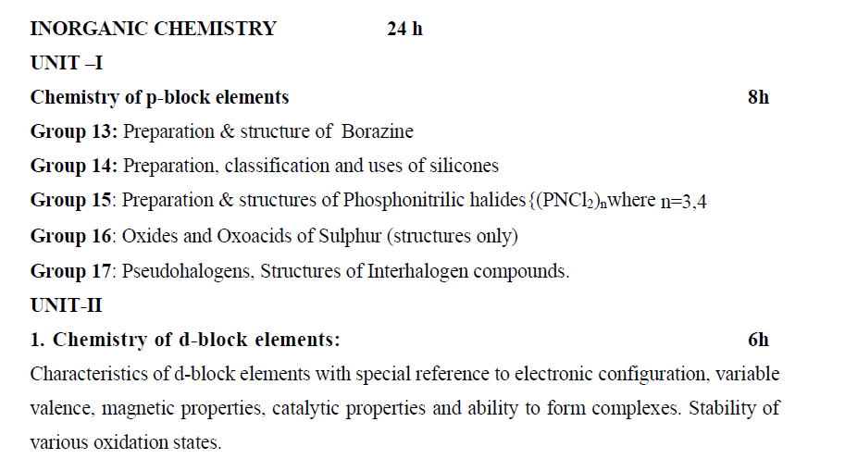

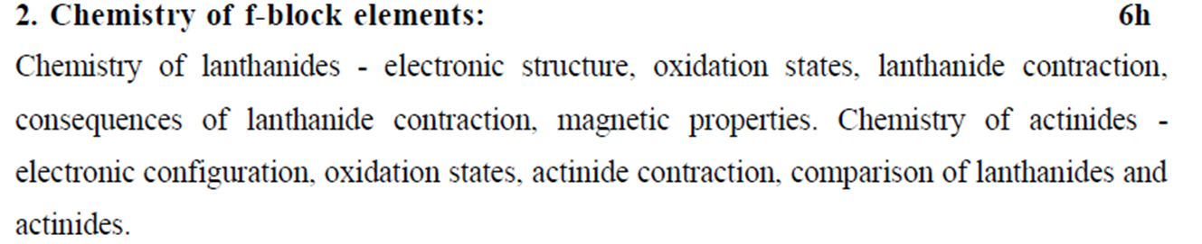

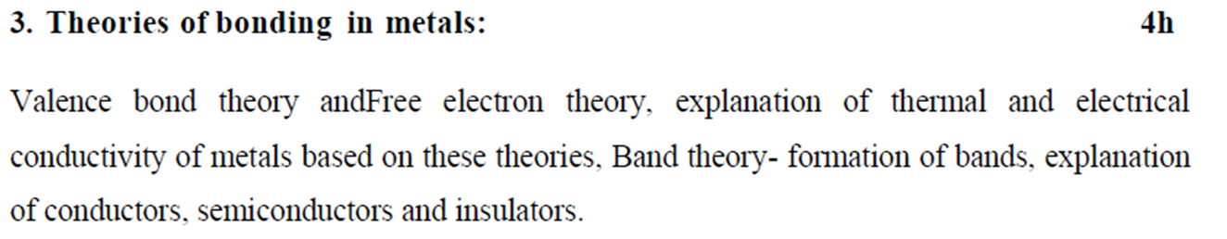

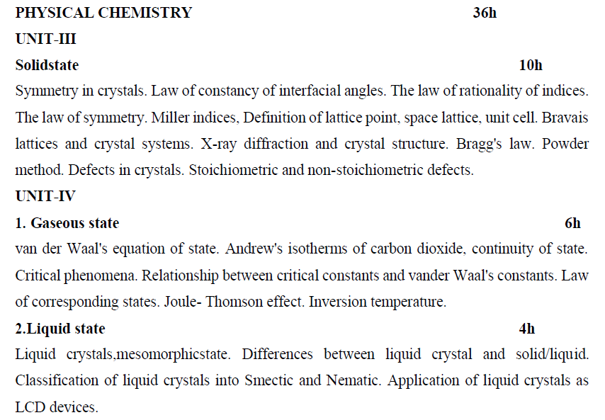

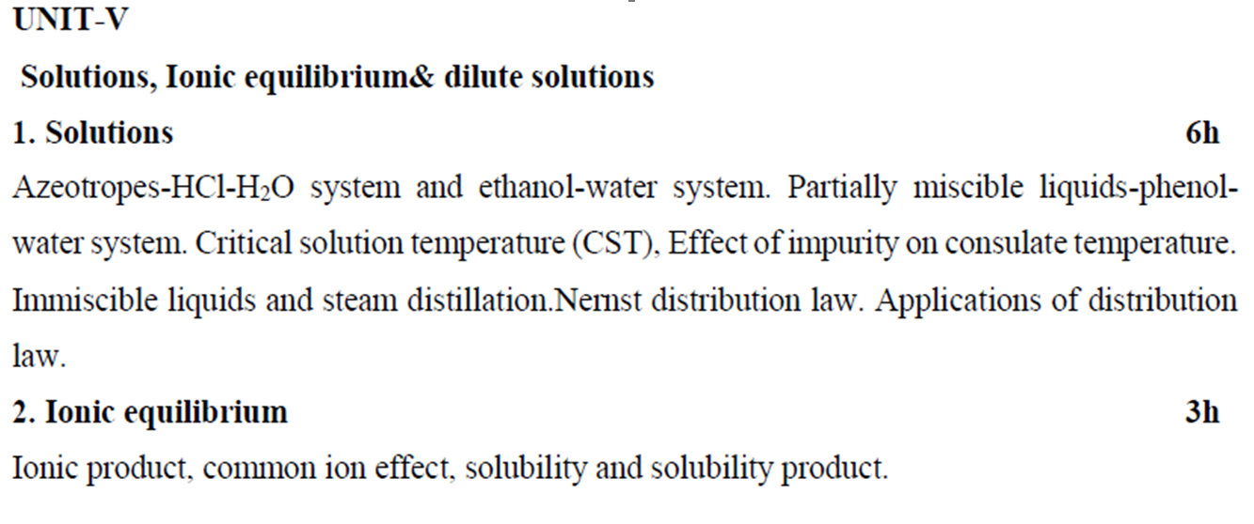

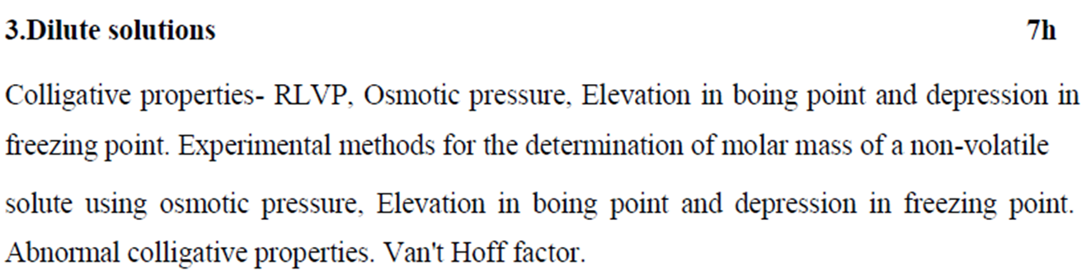

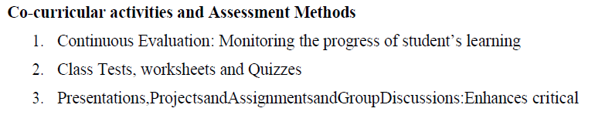

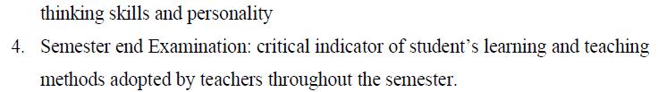

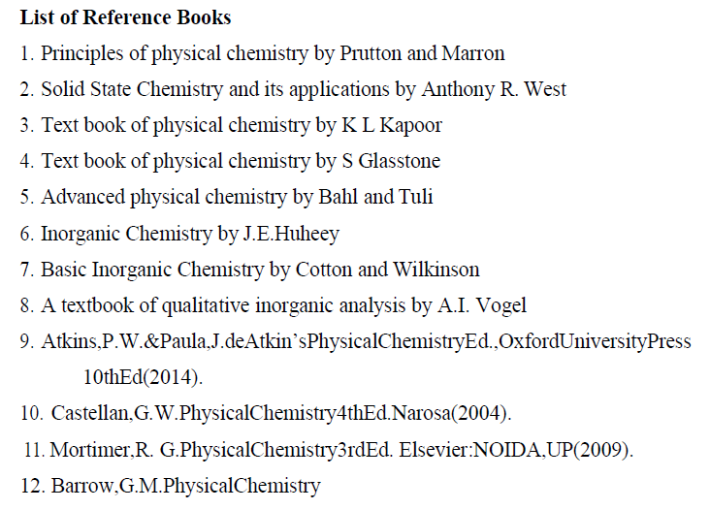

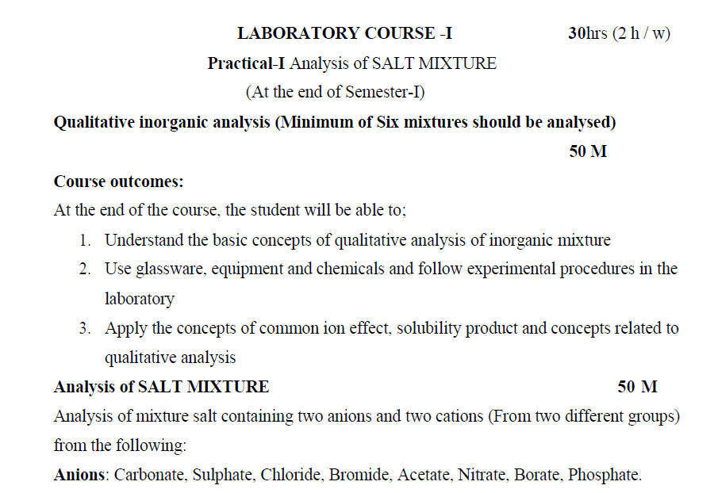



**S.K.R & S.K.R GOVT. COLLEGE FOR WOMEN (A), KADAPA**

**MODEL QUESTION PAPER**

**SUBJECT: CHEMISTRY DURATION: 3 HOURS SEMESYER: I MAX. MARKS: 60**

**TITLE OF THE PAPER: INORGANIC and PHYSICAL CHEMISTRY (PAPER-I)**

**PART- A** (5X4=20 Marks)

1. Answer any **FIVE** of the following questions. Each Carries **FOUR** marks
2. Explain the preparation and structure of Phosphonitrilic Compounds
3. Explain stability of various oxidation states of d- block elements.
4. Write short note on symmetry in crystal systems.
5. Explain Roult’s law.
6. Write an account of common ion effect and any two of its applications.
7. Describe Andrew’s isotherms of CO2.
8. Write the differences between actinides & lanthanides.
9. Explain the structure of Borazine.
10. What are Pseudo halogens. Explain briefly.
11. Write about law of corresponding states.

**PART-B** (5X8=40 Marks)

1. Answer **ALL** questions. Each question Carries **EIGHT** marks.
2. Explain classification, preparation and uses of silicones

**Or**

Discuss different types of inter halogen compounds

1. What is lanthanide contraction. Explain the consequences of it.

**Or**

Discuss the band theory of metals.

1. Write an essay on crystal defects

**Or**

Explain Bragg’s equation.

1. Derive the relationship between critical constants and Van der Waal constants.

**Or**

Give an account of liquid crystals and their applications.

1. Explain Nernst distribution law and its application.

**Or**

Explain the relation between molar mass of a non-volatile solute and elevation in boiling point. Give the experimental method for the determination of elevation in boiling point.

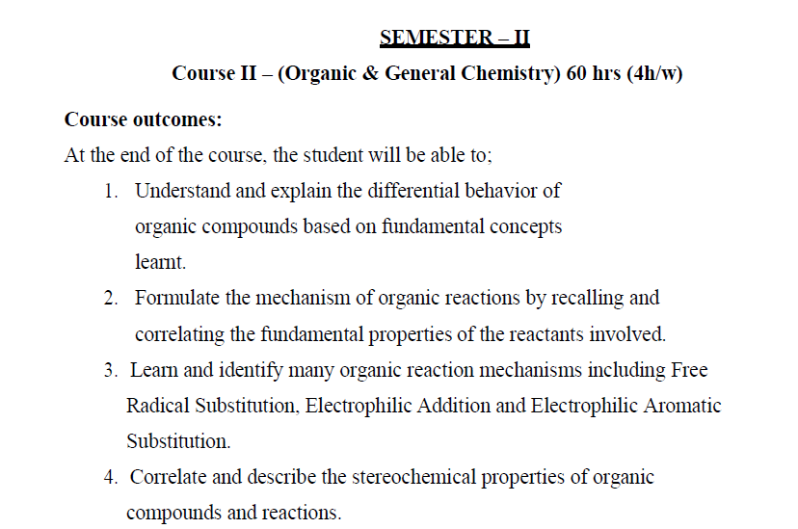

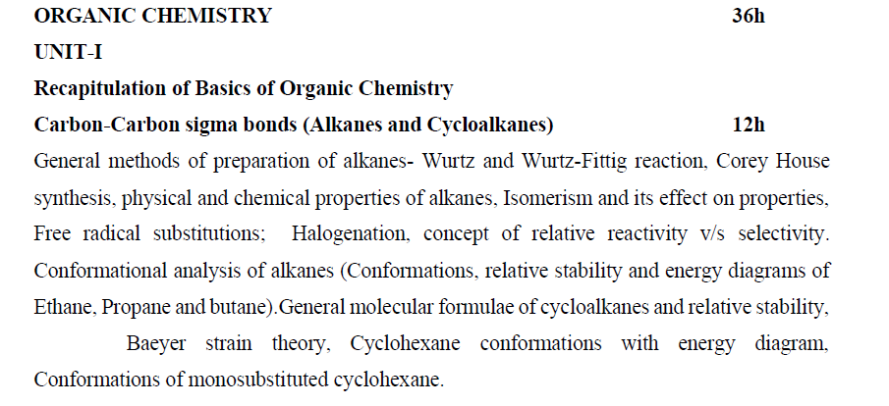

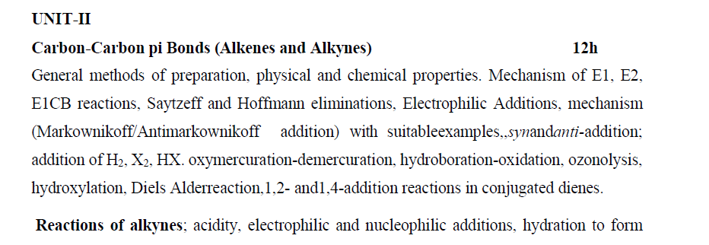

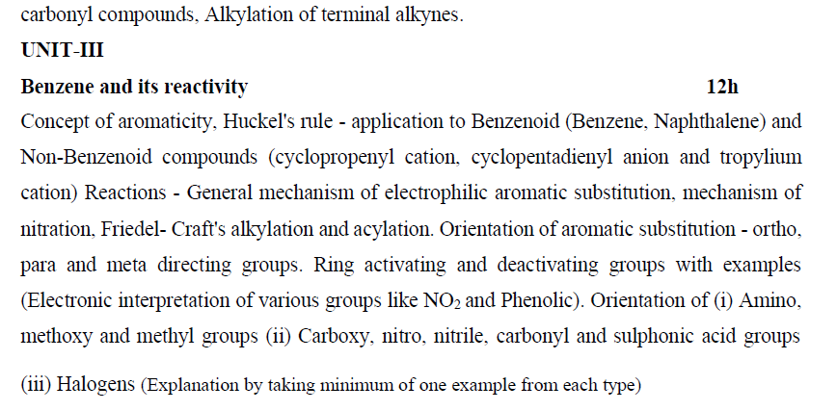

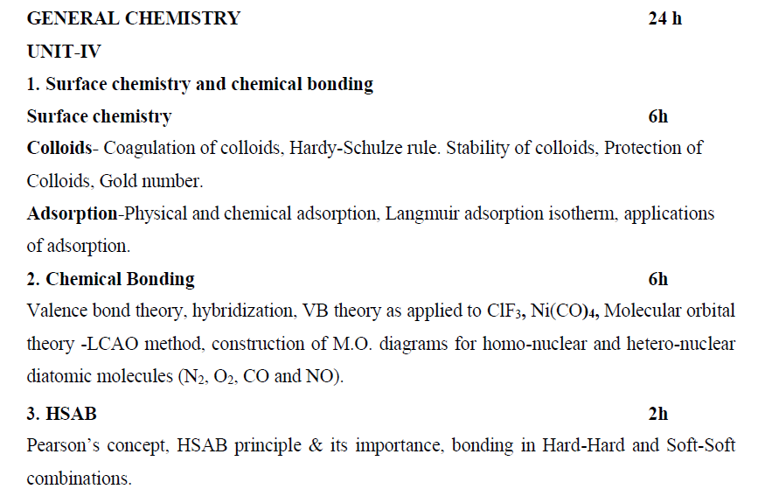

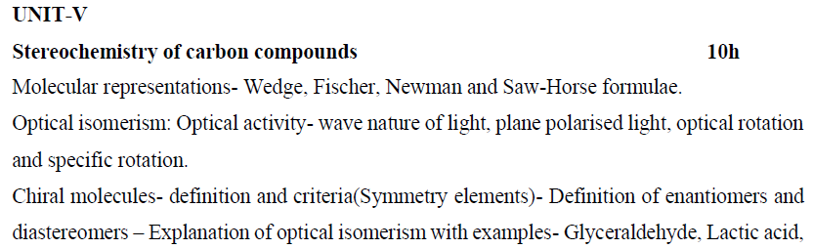

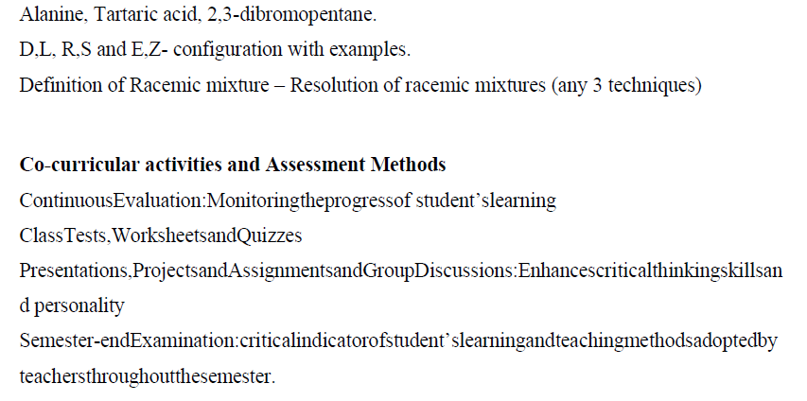

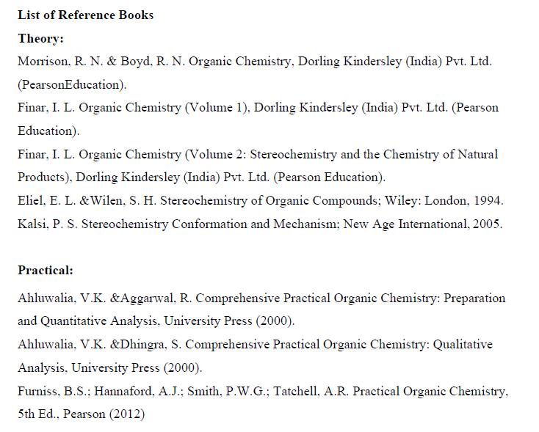



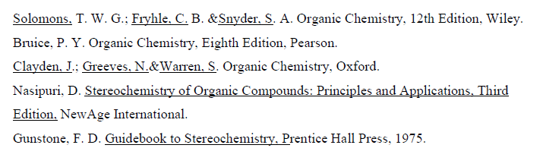

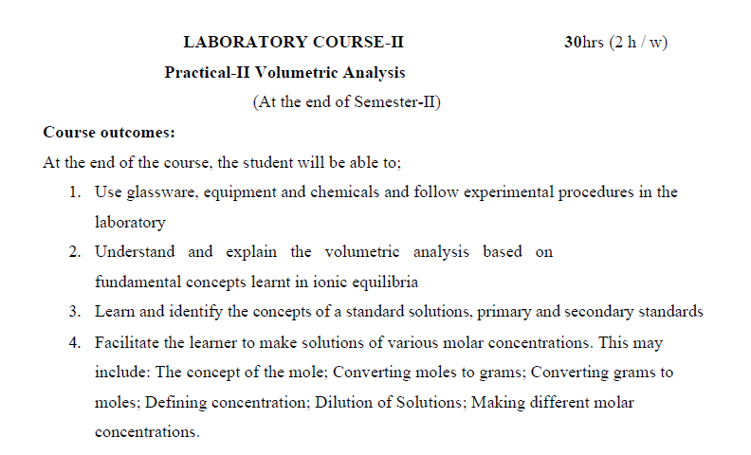

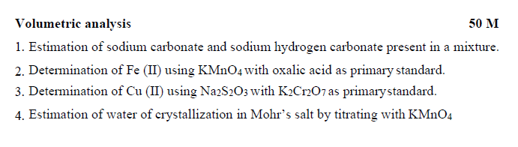

**S.K.R & S.K.R GOVT. COLLEGE FOR WOMEN (A), KADAPA**

**MODEL QUESTION PAPER**

**SUBJECT: CHEMISTRY DURATION: 3 HOURS**

**SEMESYER: II MAX. MARKS: 60**

**TITLE OF THE PAPER: ORGANIC and GENERAL CHEMISTRY (PAPER-II)**

**PART- A** (5X4=20 Marks)

1. Answer any **FIVE** of the following questions. Each Carries **FOUR** marks
2. Explain Conformational isomers of n-butane.
3. Explain 1,2 and 1,4 addition reactions of 1,3 butadiene.
4. Explain the orientation of aromatic substitution in benzene.
5. Explain the mechanism of E1 & E2 elimination reactions.
6. Explain the structure of ClF3 by valence bond theory.
7. What are hard and soft acids and bases. Explain with examples.
8. Explain the optical isomerism in tartaric acid.
9. Define enantiomers and diastereomers and give two examples for each.
10. Explain Gold number.
11. Explain the halogenation reactions of benzene.

**PART-B** (5X8=40 Marks)

1. Answer **ALL** questions. Each question Carries **EIGHT** marks.
2. a) Write the preparation of alkanes by Wurtz and Corey-House reaction.

b) Explain halogenation of alkanes. Explain the reactivity in free radical substitution.

**Or**

Explain Bayer’s strain theory and draw the confirmations of cyclohexane.

1. Explain the mechanism of Markonikoff’s and anti-Markonikoff’s addition of HBr to alkene.

**Or**

1. Explain the acidity of 1-alkynes.
2. How will you prepare acetaldehyde and acetone from alkynes?
3. Define Huckel’s rule of aromatic compounds. What are benzenoid and non-benzenoid aromatic compounds. Give examples.

**Or**

Explain the mechanism of nitration and Friedel-Craft’s alkylation of benzene.

1. Differentiate Physisorption and Chemisorption. Explain Langmuir adsorption isotherm.

**Or**

Construct the molecular orbital diagrams for O2, NO and explain their bond order &

magnetic property.

1. Define Racemic mixture. Explain any two techniques for the resolution of racemic mixture.

**Or**

Explain R-S and E-Z configurations with examples.